**Name (netid):** Ruisen Tu (ruisent2)

**CS 445 - Project 2: Image Quilting**

Complete the claimed points and sections below.

**Total Points Claimed [ 100 ] / 175**

**Core**

1. Randomly Sampled Texture [ 10 ] / 10
2. Overlapping Patches [ 20 ] / 20
3. Seam Finding [ 20 ] / 20
4. Additional Quilting Results [ 10 ] / 10
5. Texture Transfer [ 30 ] / 30
6. Quality of results / report [ 10 ] / 10

**B&W**

1. Iterative Texture Transfer [ ] / 15
2. Face-in-Toast Image [ ] / 20
3. Hole filling w/ priority function [ ] / 40

**1. Randomly Sampled Texture**

Include

* Sample and output images
* Sample: Output:

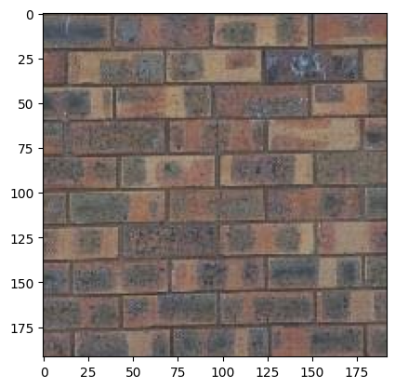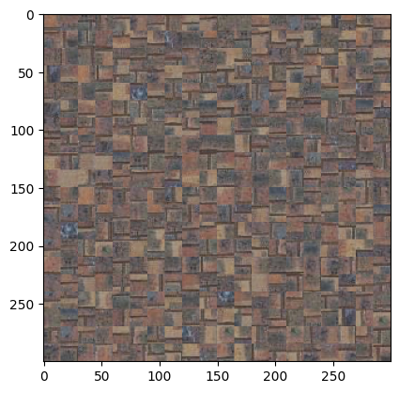

* Parameters: patch size, output size

patch size = 15, output size = 300

**2. Overlapping Patches**

Include

* Output image for same sample as part 1

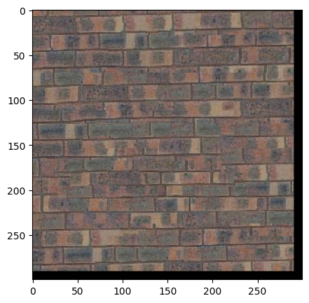

* Parameters: patch size, overlap size, tolerance

patch size = 300, overlap size = 11, tolerance = 3

**3. Seam Finding**

Include

* Output image for same sample as part 1

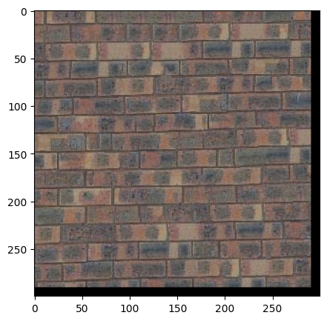

* Illustration: for a selected patch, display (a) the two overlapping portions; (b) pixelwise SSD cost; (c) horizontal mask; (d) vertical mask; (e) combination mask. The mask is binary and tells which pixels come from which patch.
  + Note: we’ll accept anything that looks like a genuine attempt to meet illustration instructions. (a) was intended to mean the two RGB patches (template and selected) that are being cut; (b) can be the SSD values of all the overlapping pixels (i.e. per-pixel SSD masked by template mask), or either one of the SSDs that you feed into cut.

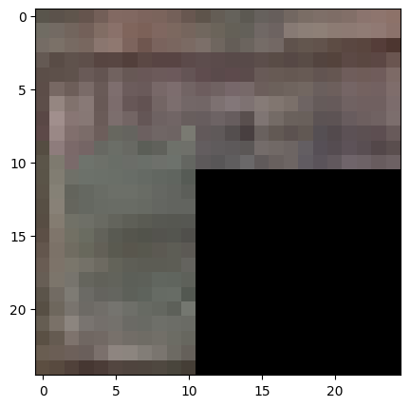

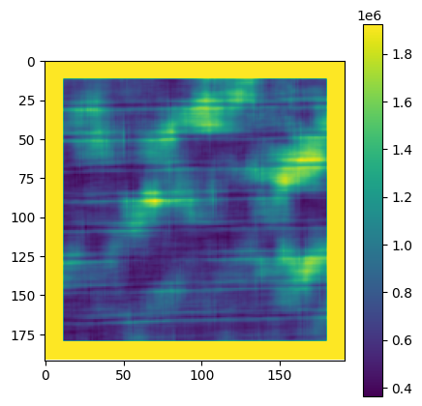

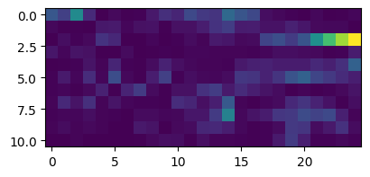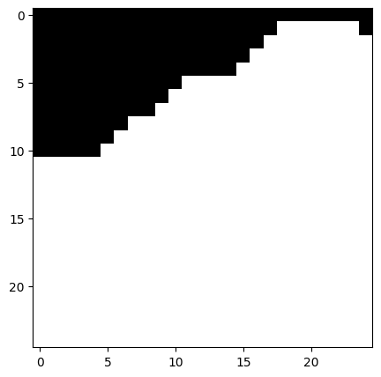

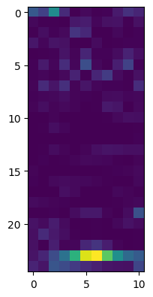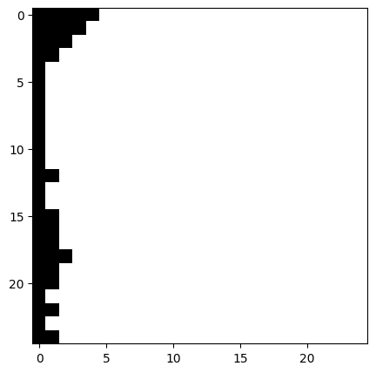

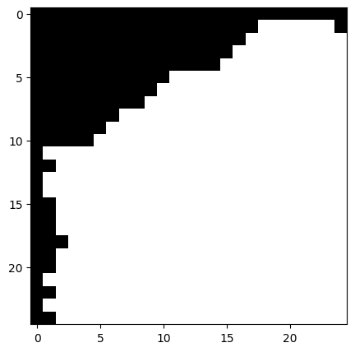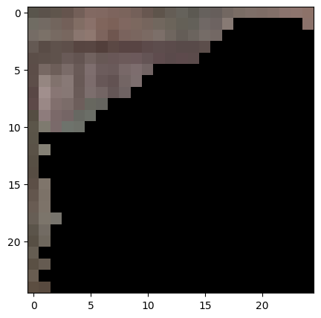

**4. Additional Quilting Results**

Include

* At least two quilting results on your own images (excluding provided samples). Each result should show input texture image and output, and output should be more pixels than input.

texture image1 output1

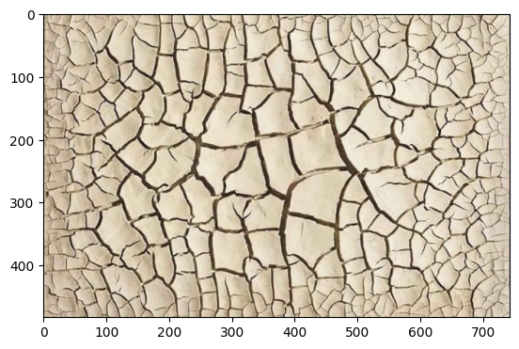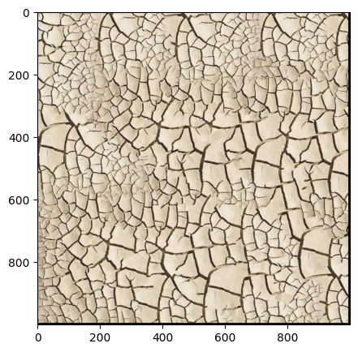

texture image2 output2

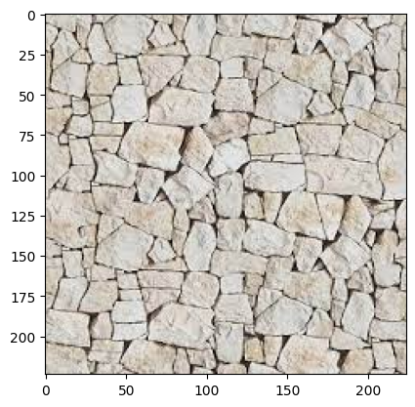 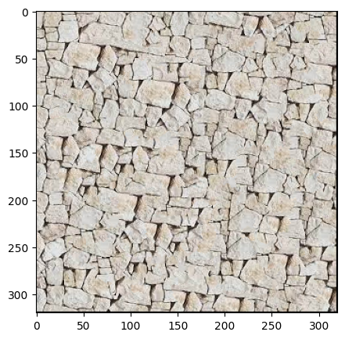

**5. Texture Transfer**

Include

* Brief description of texture transfer method and parameters
  + For each patch in the target image, we want to choose a patch of the same from the texture image and put it in the same position in the output image. For each possible patch in the texture image, we calculate (1) the ssd cost of its overlapping portions with the patches on its top and its left (*SSD_overlap*); (2) the ssd cost between this patch and the patch in the target image (*SSD_transfer*). The *total cost = alpha*SSD_overlap + (1-alpha)*SSD_transfer*, which allows us to find a balance between these two costs. At last, we randomly choose one patch from the *tol* patches corresponding to the *tol* smallest *total cost* and paste to the output image.
  + patch_size = 25, overlap = 11, tol = 5, alpha = 0.1
* At least two texture transfer results (one result can use provided samples). Include the input texture and target images and the output (output should be same size as target image)
  + Result1:

texture image target image output

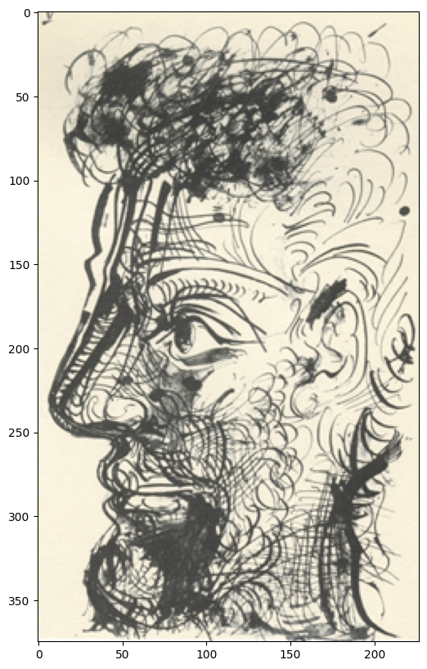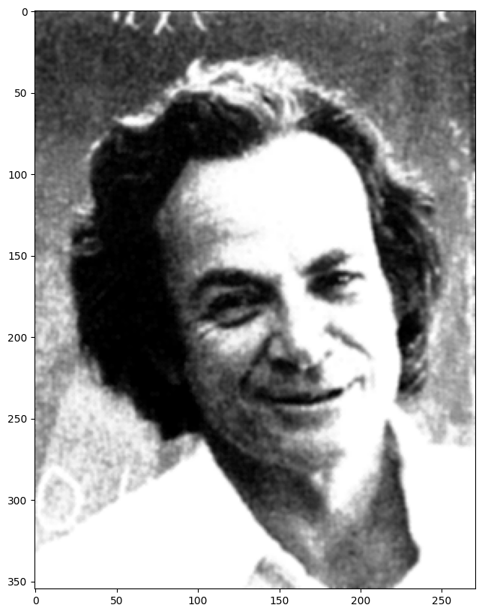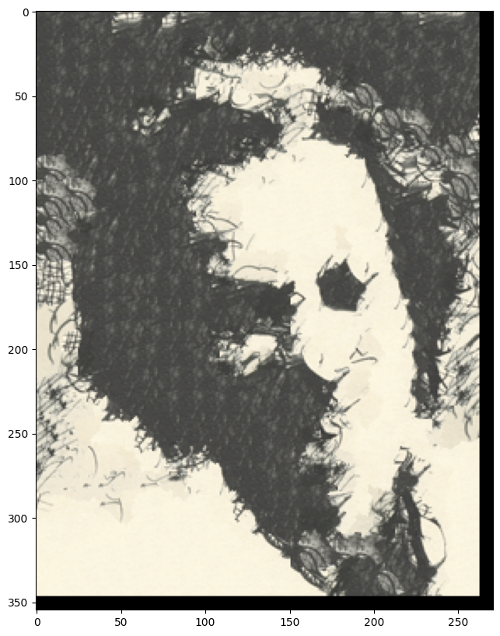

* + Result2:

texture image target image output

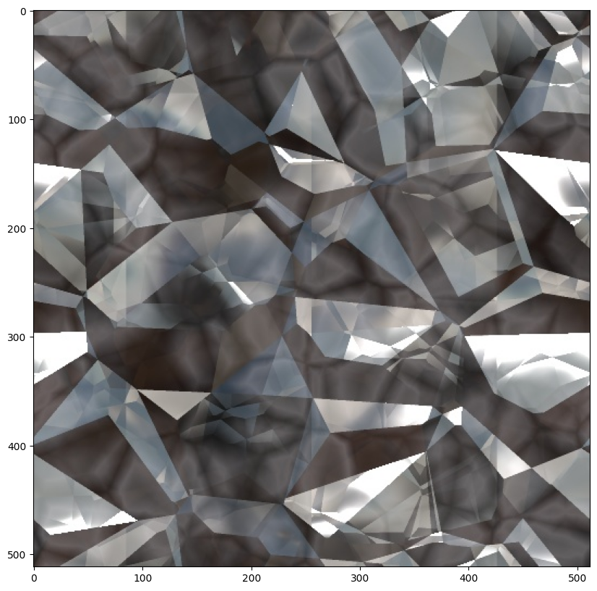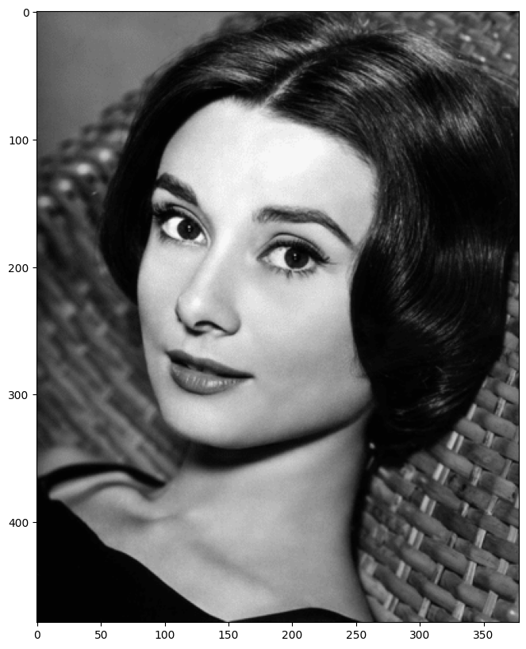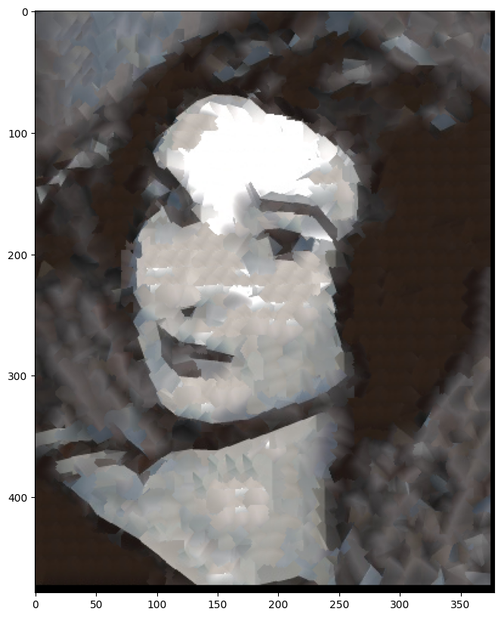

**6. Quality of results / report**

Nothing extra to include (scoring: 0=poor 5=average 10=great).

**7. Iterative Texture Transfer (B&W)**

Include

* Describe method
* Results on same images as shown for texture transfer.

**8. Face-in-Toast Image (B&W)**

Include

* Describe method
* Show input face image, toast image, and final result

**9. Hole filling w/ priority function (B&W)**

Include

* Describe method
* Show result on at least two images (show input with hole and output)

**Acknowledgments / Attribution**

List any sources for code or images from outside sources